|  |
| --- |
| Southern Area Superintendent’s Office **2017-2018** |

|  |  |
| --- | --- |
| **School** | Vance Elementary |
| **Submitted By** | Vicki Wood |
| **Submission Date** | August 14, 2017 |

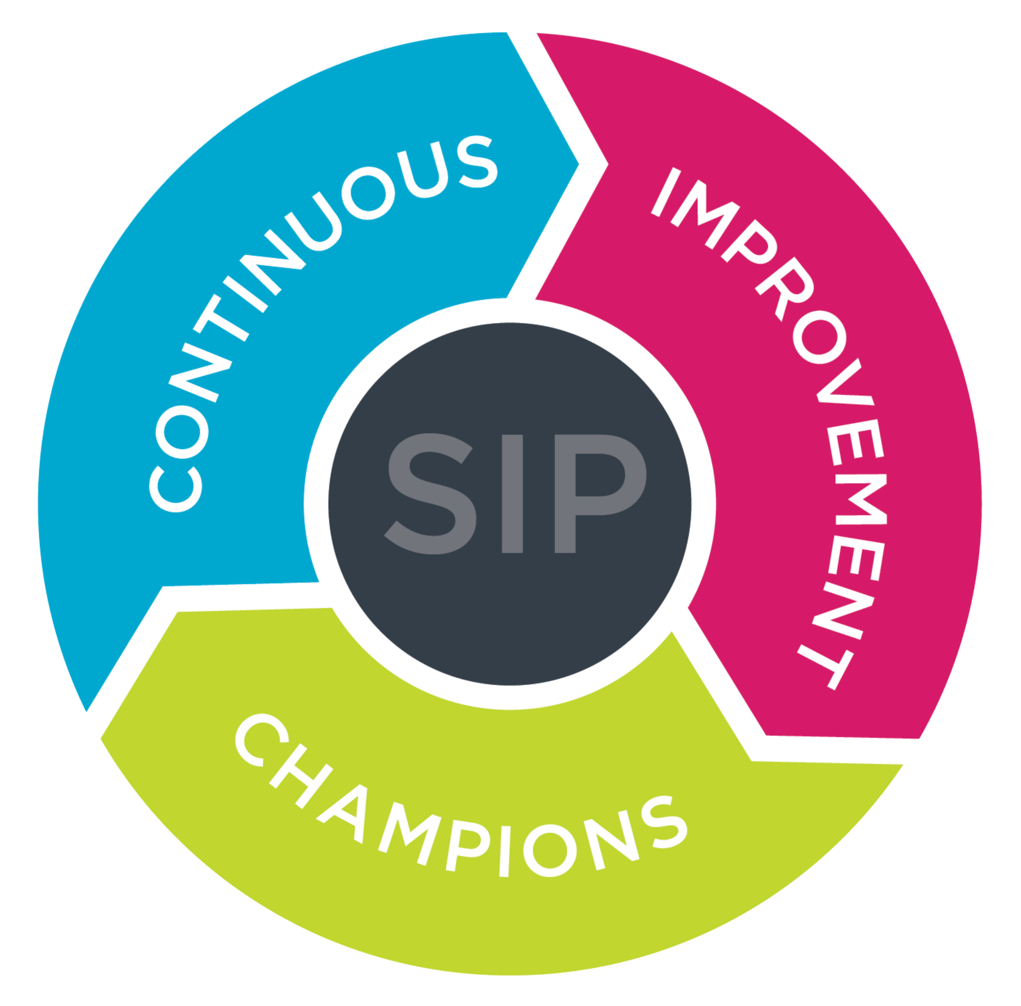

**School Improvement Team Meetings**

**Please star (*) the meeting dates that will be your quarterly reviews. If a quarterly review does not fall on a regularly scheduled SIP meeting, add it to the list as a separate meeting date. Thank you!**

|  |  |  |  |
| --- | --- | --- | --- |
| **Day** | **Date** | **Time** | **Location** |
| **Monday** | **July 24, 2017** | 2:00 | Media Center |
| **Wednesday** | August 9, 2017 | 4:15 | Media Center |
| **Wednesday** | September 6, 2017 | 4:15 | Media Center |
| **\*Friday** | October 20, 2017 | 2:00 | Media Center |
| **Wednesday** | November 15, 2017 | 4:15 | Media Center |
| **Wednesday** | December 13, 2017 | 4:15 | Media Center |
| **\*Wednesday** | January 19, 2017 | 2:00 | Media Center |
| **Wednesday** | February 7, 2018 | 4:15 | Media Center |
| **Wednesday** | March 7, 2018 | 4:15 | Media Center |
| **\*Wednesday** | April 18, 2018 | 2:00 | Media Center |
| **Wednesday** | May 9, 2018 | 4:15 | Media Center |
| **Wednesday** | June 13, 2018 | 4:15 | Media Center |

*4th Quarter Review will take place in July once all EOG data and EOY data is complete.